Efficient Pin Upload SOP
We get the best results with 8-12 pins/day. This is what I'd recommend to you too.

Efficient Pin Upload
- If you have multiple accounts, turn on your VPN (always use the same location for one account group, max. 10 accounts in one group). More about this here.
- Open Pinterest.
- Click "Create Pin for ad" - don't worry, it won't create an actual ad.
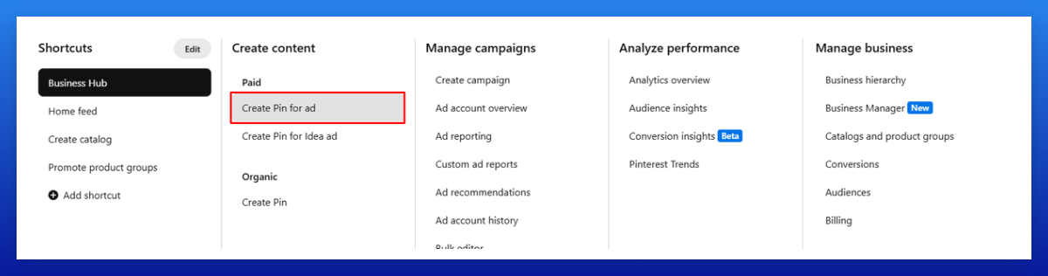
- Drag 4 images into the scheduler that'll link to the same URL.
- Click the circle in the top right > select all > click the paintbrush icon.
- For these 4 pins, choose your board, and add a title, description, and URL.
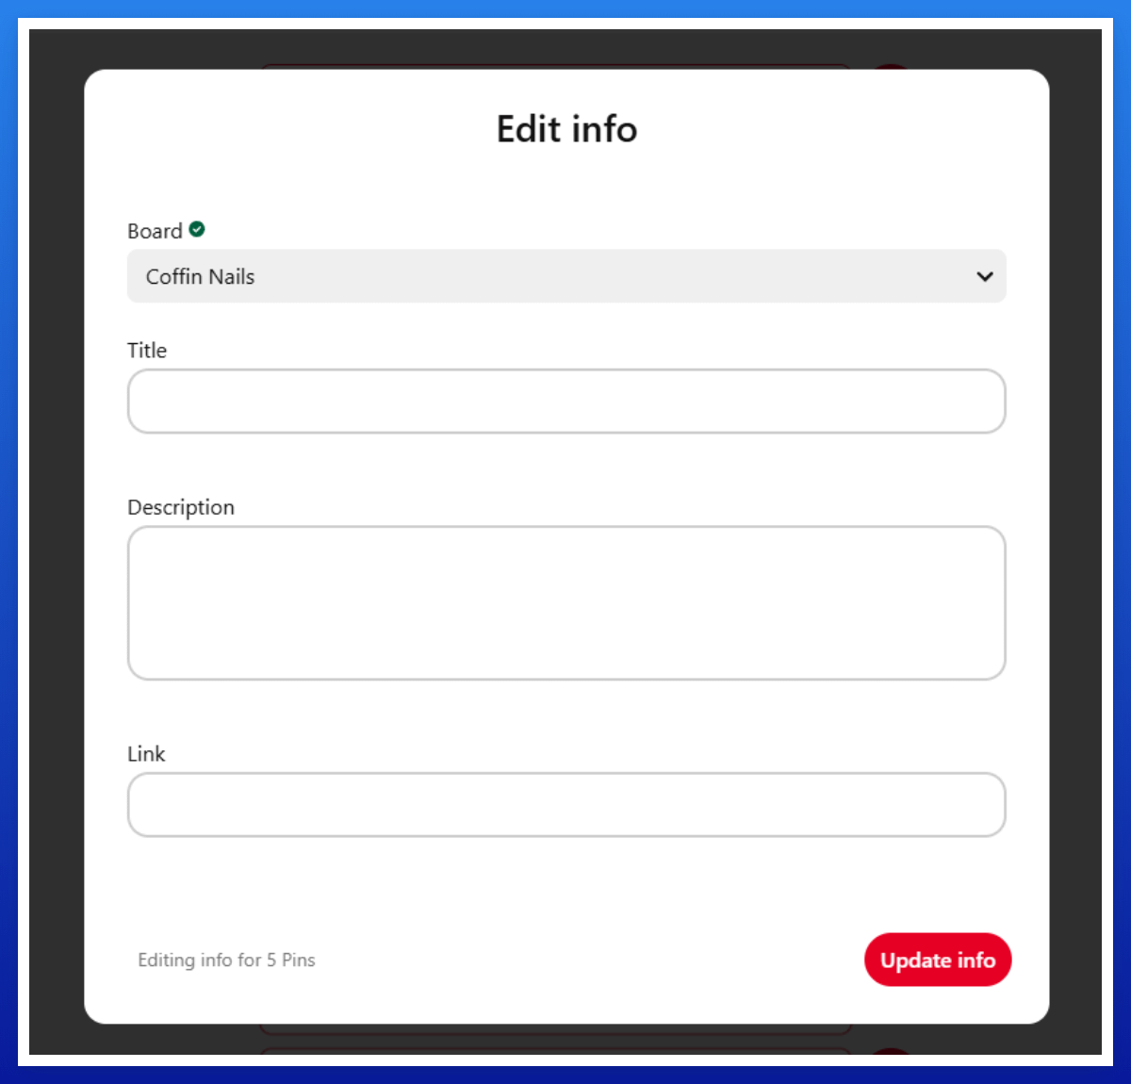
- Repeat this with 4 more pins for another article, and also add 2-4 Scout Pins without a title, description, or URL.

Note:
The risk of your account getting caught in a spam filter by uploading 4 pins to the same URL is extremely low.
In my 5 years of doing this, I've never had issues with that, and it's the oldest uploading method I use.

